**Task 4: Data Analytics Strategy**

Task Overview

**What you'll learn**

* Understand the importance of data strategy for business.
* Learn how to develop a data strategy, define data reports, and analyze data platform maturity.

**What you'll do**

* Collaborate with a team to create a PowerPoint proposal for a client's data strategy.

Here is the background information on your task

There’s no longer any doubt. We live in the age of exponential data growth. And using data in decision-making is a must-have to remain competitive.

Data assets can generate value by improving decision-making and operations including production, distribution, sales and marketing. An effective data strategy can also put data to work for the business on fraud detection and automatic content generation with AI, for example. Specific needs should be derived from the business strategy.

At PwC we develop a data strategy by creating a data vision, defining data reports and analysing data platform maturity. We develop a group-wide data strategy and enable clients to add value by helping them efficiently analyse their own data, produce reports and create dashboards.

We’re off to Bern now, to work with a Digital Intelligence team helping a client define their data strategy. The company produces a lot of data, but it is stored in many different places. Management wants to maximise the value of their data assets. Their goal is to build an infrastructure that supports the intelligent use of data within the company.

Here is your task

**You and the team are already on it. Your job is to prepare a PowerPoint slide deck with your proposal for the client. Jakob wrote you an email to get you started – check it out!**

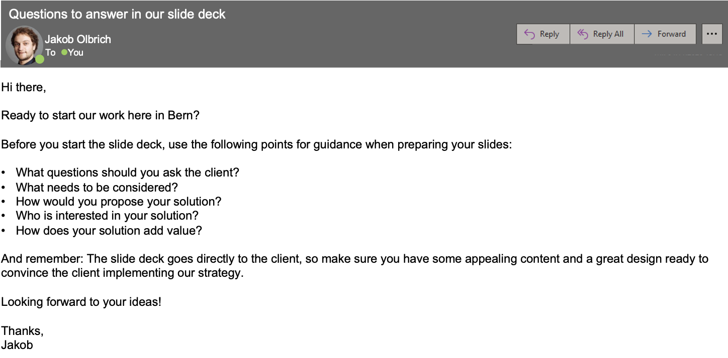

This experience is self-paced. Anyway, Jakob is expected to send the presentation to management in 1.5 hours and needs your input as soon as possible. We recommend you spend no more than that completing this task.

Here are some resources to help you

Use the resources below for helpful guidance on completing your task.

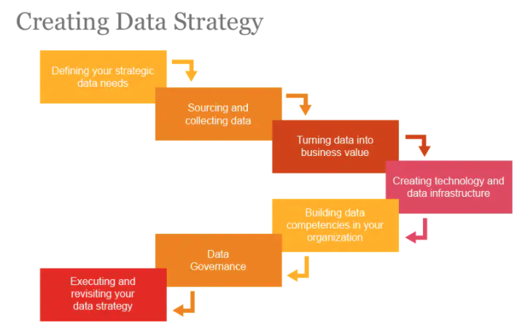

Do you want to learn more? Level up by listening to a portion (or all!) of our podcasts linked below and read our blog posts to learn more about Data Analytics Strategy to help you complete the task.

**Podcasts**

* [Transforming risk into confidence series: Managing data during a business and technology transformation](https://www.pwc.com/us/en/services/consulting/risk-regulatory/podcasts/managing-data-business-technology-transformation.html)
* [Data-driven decision making](https://podcasts.google.com/feed/aHR0cDovL2ZlZWRzLmZlZWRidXJuZXIuY29tL2Nmb2RpcmVjdA/episode/QnV6enNwcm91dC02MTI5MjA1)

**Blog posts**

* [Which data strategy archetype are you?](https://www.pwc.ch/en/insights/digital/data-strategy-archetype.html)
* [Turning data into information and information into opportunity](https://pwc.blogs.com/technology-insights/2020/01/turning-data-into-information-and-information-into-opportunity.html)

**On top**: You must be curious about Data Analytics Strategy at PwC, so check out our [website](https://www.pwc.com/hu/en/szolgaltatasok/technologiai_tanacsadas/data_analytics/data_strategy.html)!